Hart Publishing is very pleased to announce the publication of From House of Lords to Supreme Court: Judges, Jurists and the Process of Judging Edited by James Lee

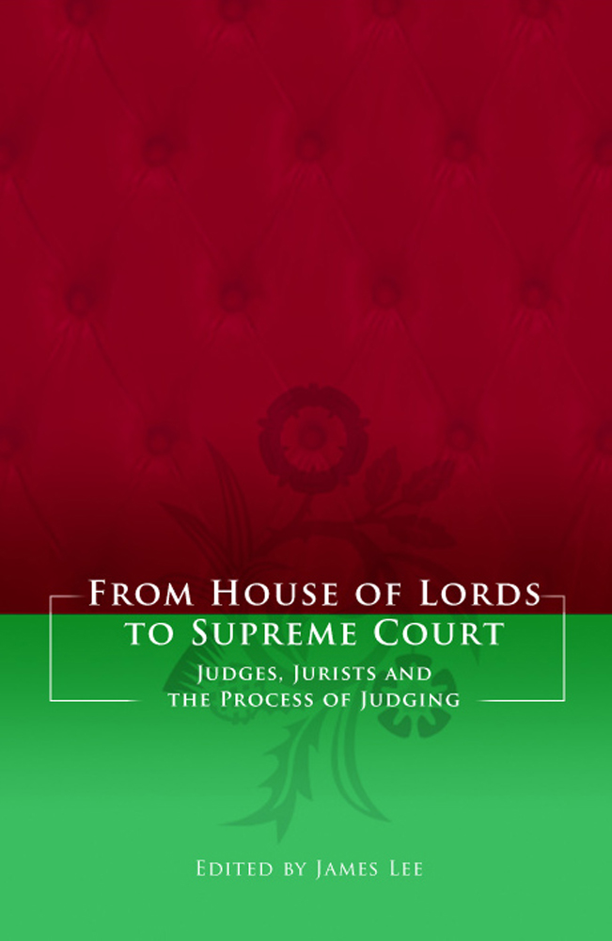
2009 saw the centenary of the Society of Legal Scholars and the transition from the House of Lords to the new Supreme Court. The papers presented in this volume arise from a seminar organised jointly by the Society of Legal Scholars and the University of Birmingham to celebrate and consider these historic events. The papers examine judicial reasoning and the interaction between judges, academics and the professions in their shared task of interpretative development of the law. The volume gathers leading authorities on the House of Lords in its judicial capacity together with academics whose specialisms lie in particular fields of law, including tort, human rights, restitution, European law and private international law. The relationship between judge and jurist is, therefore, investigated from a variety of perspectives and with reference to different jurisdictions. The aim of the volume is to reflect upon the jurisprudence of the House of Lords and to consider the prospects for judging in the new Supreme Court.

CONTENTS
1 Introduction JAMES LEE
2. A Darwinian Reflection on Judicial Values and Appointments to Final National Courts MICHAEL KIRBY
3. From Appellate Committee to UK Supreme Court: Independence, Activism and Transparency AILEEN KAVANAGH
4. Taking Women’s Property Seriously: Mrs Boland, the House of Lords, the Law Commission and the Role of Consensus ELIZABETH COOKE
5. ‘Inconsiderate Alterations in our Laws’: Legislative Reversal of Supreme Court Decisions JAMES LEE
6. (Dis)owning the Convention in the Law of Tort JENNY STEELE
7. Keeping Their Heads Above Water? European Law in the House of Lords ANTHONY ARNULL
8. The Development of Principle by a Final Court of Appeal in Matters of Private International (Common) Law ADRIAN BRIGGS
9. The Law of Unjust Enrichment in the House of Lords: Judging the Judges GRAHAM VIRGO
10. Use of Scholarship by the House of Lords in Tort cases KEITH STANTON
11. Judges and Academics: Features of a Partnership ALEXANDRA BRAUN
12. Does Advocacy Matter in the Lords? ALAN PATERSON
13. Close Calls in the House of Lords BRICE DICKSON

Please click here to view the table of contents as a PDF file:
http://www.hartpub.co.uk/pdf/1849460817.pdf

The Editor
James Lee is a Lecturer in Law at the University of Birmingham. In 2010 he was elected to a 3-Year Academic Fellowship of the Honourable Society of the Inner Temple.

Jan 2011 342pp Hbk 9781849460811 £50 / €65 / US$100 / CDN$100
DISCOUNT PRICE: £40 / €52 / US$80 / CDN$80
___________________________________________________________________________
As a member of the Restitution Discussion Group listserv Hart Publishing is delighted to offer you 20% discount.

Order Online
If you would like to order this title you can do so through the Hart Publishing website.
http://www.hartpub.co.uk/books/details.asp?isbn=9781849460811

To receive the discount please mention ref: ‘RDG’ in the special instructions field. Please note that the discount will not be shown on your order but will be applied when your order is processed.

