**Hart Publishing is delighted to give you information about their latest Contract Law title**

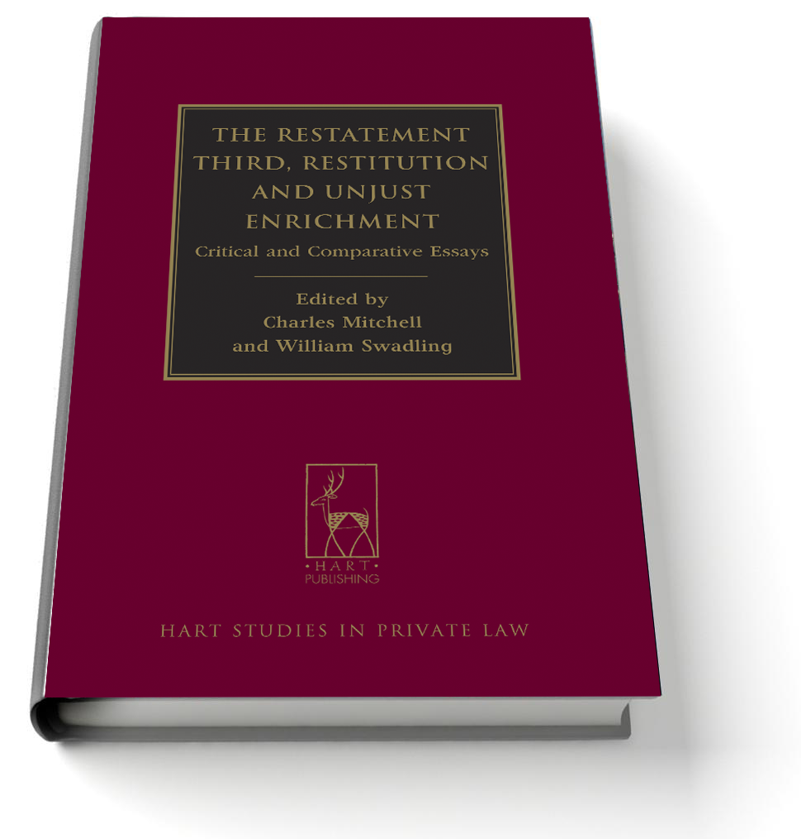**The Restatement Third: Restitution and Unjust Enrichment**

Critical and Comparative Essays

*Edited by Charles Mitchell and William Swadling*

The publication of the Restatement Third: Unjust Enrichment and Restitution by the American Law Institute in July 2010 was an event of major importance, not only for the development of the law of unjust enrichment in the US, but also for global scholarship relating to this area of private law. The Restatement First appeared in 1937, and the Restatement Second was abandoned; hence the Restatement Third is the most significant survey of the American law on this topic for over 70 years. Private law has been a comparatively neglected area of study in US law schools for several decades, and this is particularly true of the law of unjust enrichment. However, the appearance of the Restatement Third has prompted a renewal of interest in the subject among US scholars, and it is hoped that the present volume of essays will contribute to this revival, while reflecting on the lessons to be learned from the Restatement by other legal systems. Featuring the work of leading scholars from the UK, Germany, South Africa, Canada, Hong Kong and Australia, the essays undertake critical and comparative analysis of the Restatement, and offer fresh insights into the rules that it articulates.

***Charles Mitchell*** *is a Professor of Law at University College London.*

***William Swadling*** *is a Reader in the Law of Property at the University of Oxford and a Fellow of Brasenose College.*

[Please click here to view the table of contents for this book](http://www.hartpub.co.uk/pdf/9781849464086.pdf)

May 2013 338pp Hbk 9781849464086 RSP: ~~£65 / €84.50 / CDN$130~~

***Discount Price: £52 / €67.60 / CDN$104***

**As a member of the Restitution Discussion Group Hart Publishing is delighted to offer you 20% discount.**

**ORDER ON-LINE**Please click on the link below to order online. When ordering online please type the reference 'RDG' in the voucher code field and click ‘apply’ to receive the discount.

<http://www.hartpub.co.uk/BookDetails.aspx?ISBN=9781849464086>

Alternatively, please contact Hart Publishing and quote reference ‘RDG’ to receive the 20% discount.  
  
Hart Publishing Ltd, 16C Worcester Place Oxford OX1 2JW, UK  
Tel: +44 (0)1865 517530 Fax: +44 (0)1865 510710

E-mail: [mail@hartpub.co.uk](mailto:mail@hartpub.co.uk); Website: <http://www.hartpub.co.uk>